**Experiment 2.2**

**Student Name: Rahul Kumar UID: 20BCS7081**

**Branch: BE-CSE Section/Group:20BCS_DM-716 B**

**Semester: 6 Date of Performance: 28 March 2023**

**Subject Name: DM LAB Subject Code: 20CSP_376**

**AIM :-**

To perform the classification by Naïve Bayes induction using WEKA tools

**Theory And Output :-**

Naive Bayes is a Supervised Non-linear classification algorithm in R Programming. Naive Bayes classifiers are a family of simple probabilistic classifiers based on applying Baye’s theorem with strong(Naive) independence assumptions between the features or variables. The Naive Bayes algorithm is called “Naive” because it makes the assumption that the occurrence of a certain feature is independent of the occurrence of other features.

#### Theory

Naive Bayes algorithm is based on Bayes theorem. Bayes theorem gives the conditional probability of an event A given another event B has occurred.

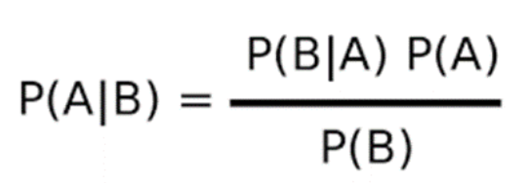

* ***where,****P(A|B) = Conditional probability of A given B.   
  P(B|A) = Conditional probability of B given A.   
  P(A) = Probability of event A.   
  P(B) = Probability of event B.*

For many predictors, we can formulate the posterior probability as follows

***P(A|B)****= P(B1|A) * P(B2|A) * P(B3|A) * P(B4|A) …*

#### The Dataset

**Iris** dataset consists of 50 samples from each of 3 species of Iris(Iris setosa, Iris virginica, Iris versicolor) and a multivariate dataset introduced by British statistician and biologist Ronald Fisher in his 1936 paper The use of multiple measurements in taxonomic problems. Four features were measured from each sample i.e length and width of the sepals and petals and based on the combination of these four features,

# Loading data

data(iris)

# Structure

str(iris)

#### Performing Naive Bayes on Dataset

Using Naive Bayes algorithm on the dataset which includes 11 persons and 6 variables or attributes

# Installing Packages

install.packages("e1071")

install.packages("caTools")

install.packages("caret")

# Loading package

library(e1071)

library(caTools)

library(caret)

# Splitting data into train

# and test data

split <- sample.split(iris, SplitRatio = 0.7)

train_cl <- subset(iris, split == "TRUE")

test_cl <- subset(iris, split == "FALSE")

# Feature Scaling

train_scale <- scale(train_cl[, 1:4])

test_scale <- scale(test_cl[, 1:4])

# Fitting Naive Bayes Model

# to training dataset

set.seed(120)  # Setting Seed

classifier_cl <- naiveBayes(Species ~ ., data = train_cl)

classifier_cl

# Predicting on test data'

y_pred <- predict(classifier_cl, newdata = test_cl)

# Confusion Matrix

cm <- table(test_cl$Species, y_pred)

# Model Evaluation

confusionMatrix(cm)

#### Output:

**Model classifier:**  
  
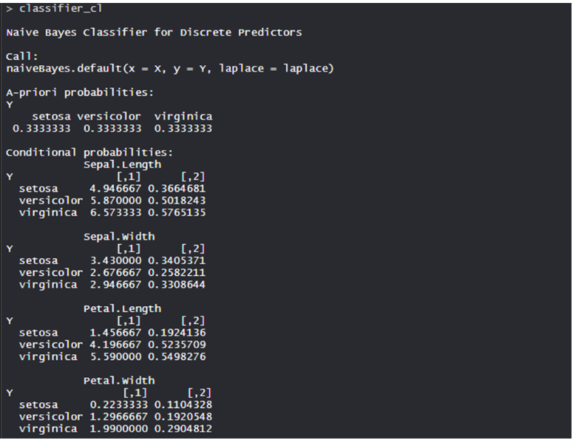

·         The Conditional probability for each feature or variable is created by model separately. The apriori probabilities are also calculated which indicates the distribution of our data.

**Confusion Matrix:**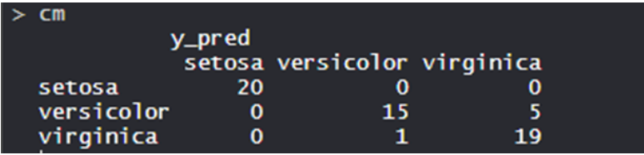

·         So, 20 Setosa are correctly classified as Setosa. Out of 16 Versicolor, 15 Versicolor are correctly classified as Versicolor, and 1 are classified as virginica. Out of 24 virginica, 19 virginica are correctly classified as virginica and 5 are classified as Versicolor.

·         **Model Evaluation:**   
 